**How would you integrate the different motivation theories together? Diagram your model of motivation. Which theories you think is most effective in keeping the motivation level high**

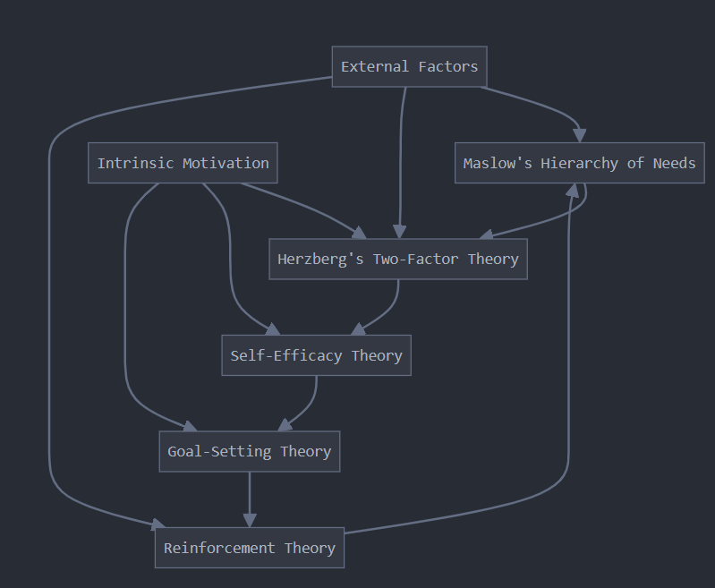

I believe Self-Efficacy Theory is particularly powerful for several reasons:

1. Unlike external rewards (Reinforcement Theory) or temporary goal achievement (Goal-Setting Theory), self-efficacy creates a lasting belief in one's abilities.
2. High self-efficacy positively influences goal setting, perseverance, and resilience in the face of challenges.
3. As individuals experience success, their self-efficacy increases, creating a positive feedback loop.
4. Self-efficacy is applicable across various domains and situations, making it a flexible tool for maintaining motivation.
5. It aligns closely with intrinsic motivation, which is generally more sustainable than extrinsic motivation.